**Practical No: 2B**

**Aim: Use Cain and Abel for cracking Windows account password using Dictionary attack and to**

**decode wireless network passwords**

**Steps: -**

**Open Cain Software**

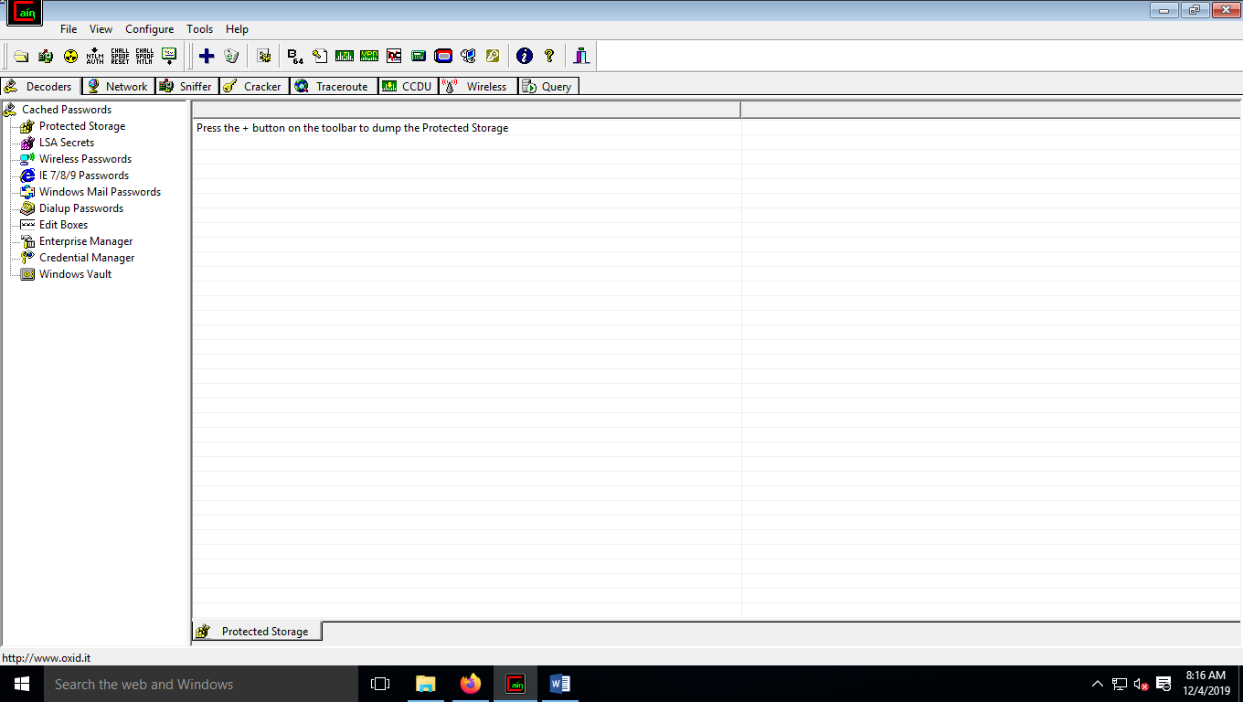

**Click on hash calculator and enter any values and click on calculate**

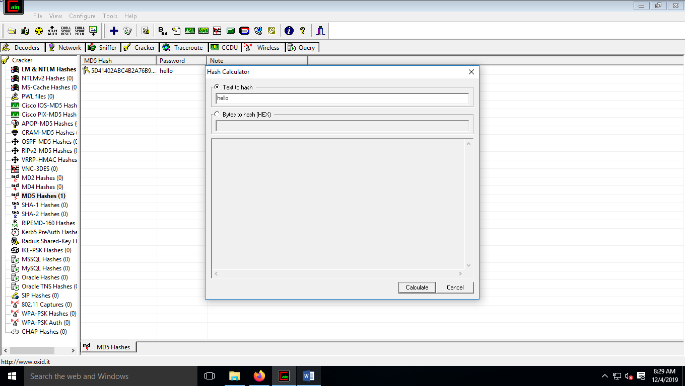

**Copy the MD5 values**

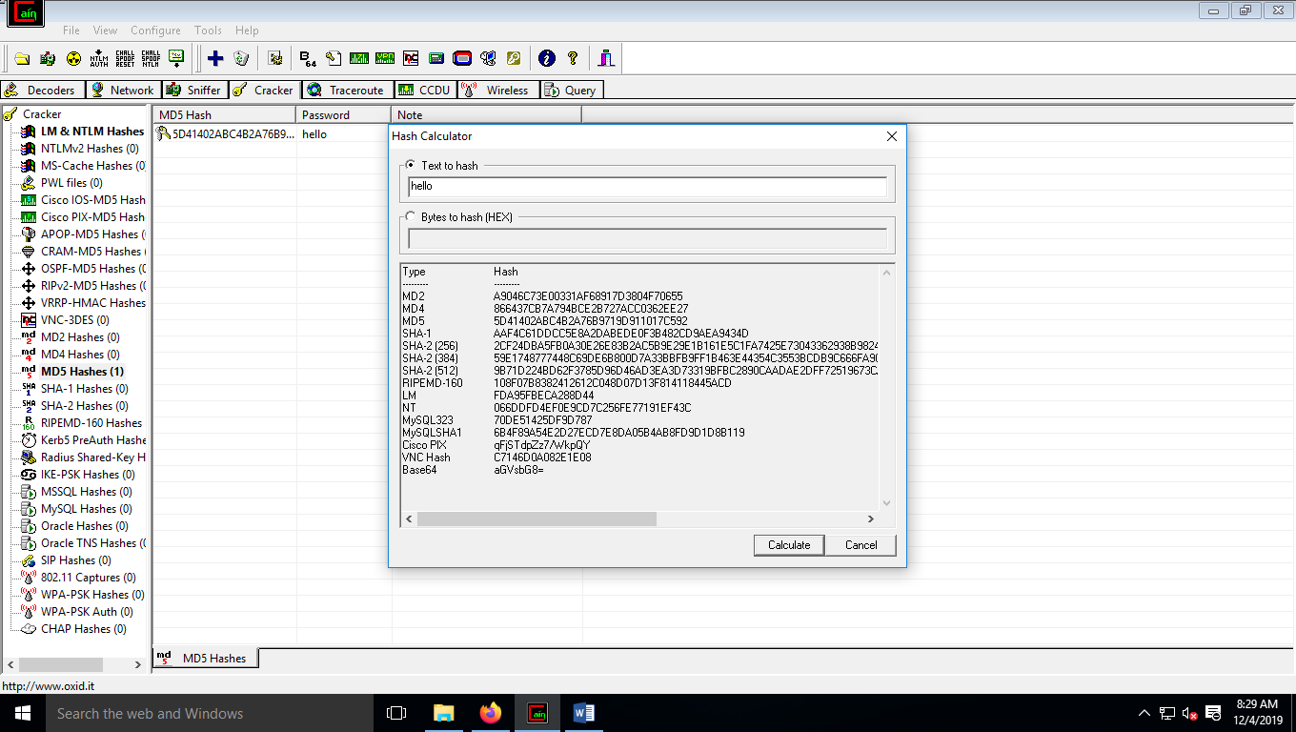

**Click on cracker from menu tab and click on MD5 Hashes(0)**

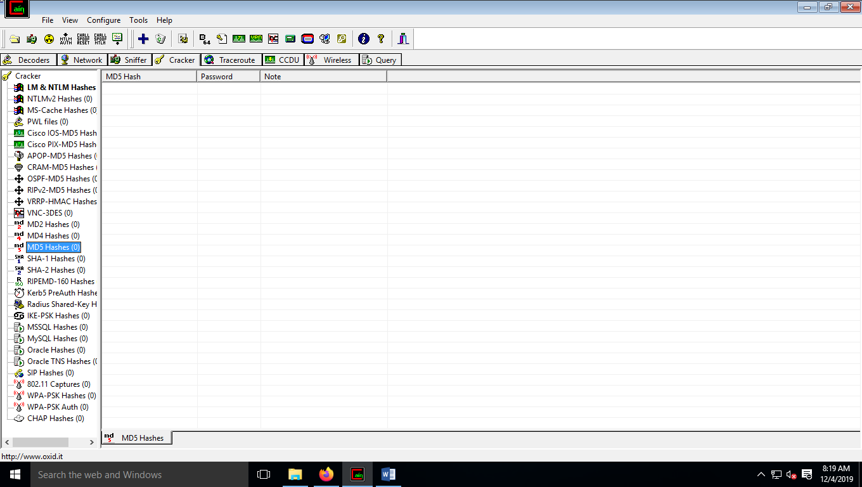

**Right click on open space and click on Add to list**

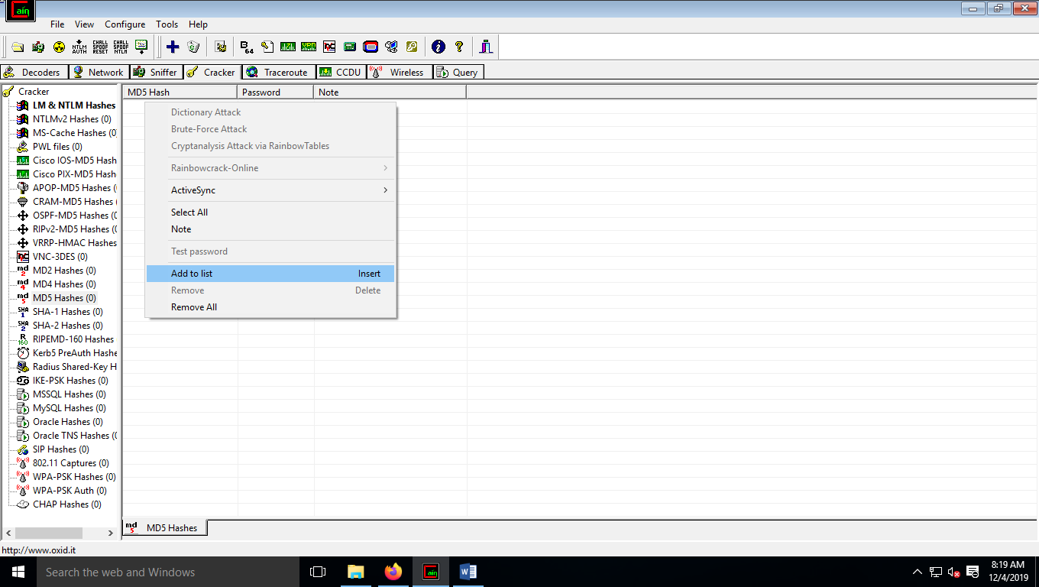

**Paste the copied MD5 value in the box and click on ok**

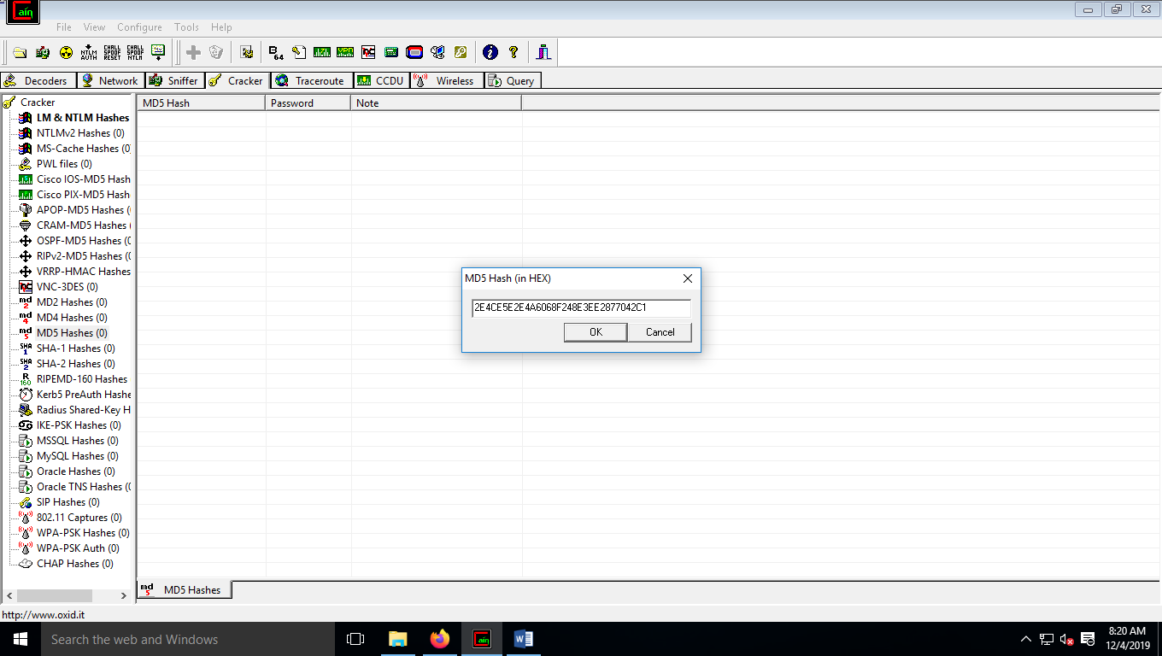

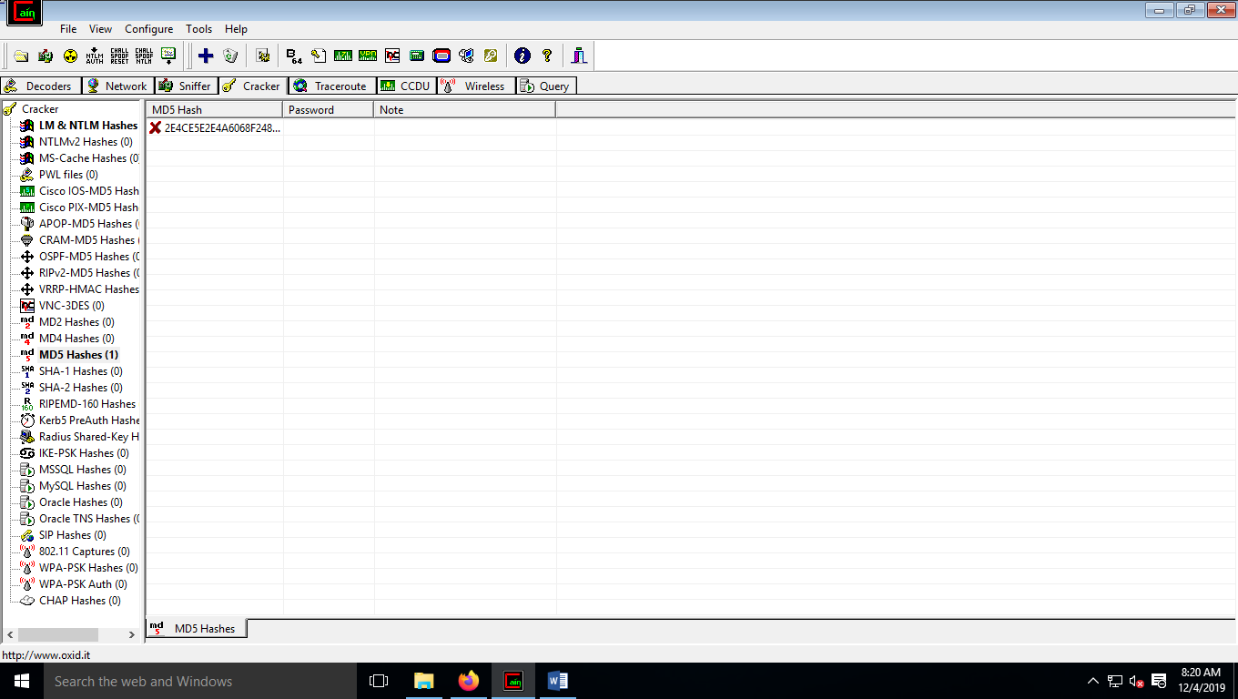

**Right click on the new value which is appeared and click on Dictionary attack**

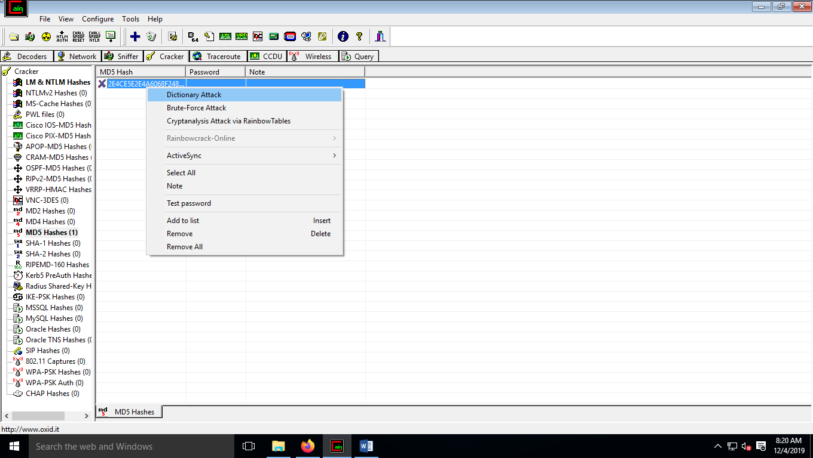

**Right click on the dictionary file and click on the add to list**

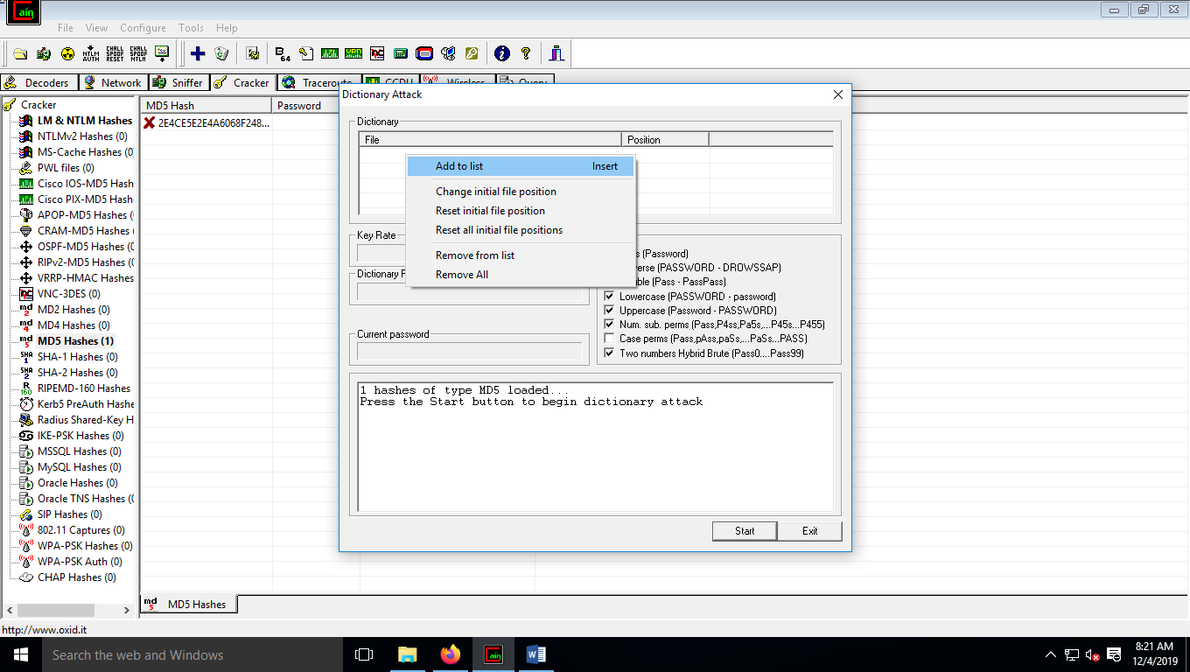

**Select the wordlist from the cain folder and click on openand click on start**

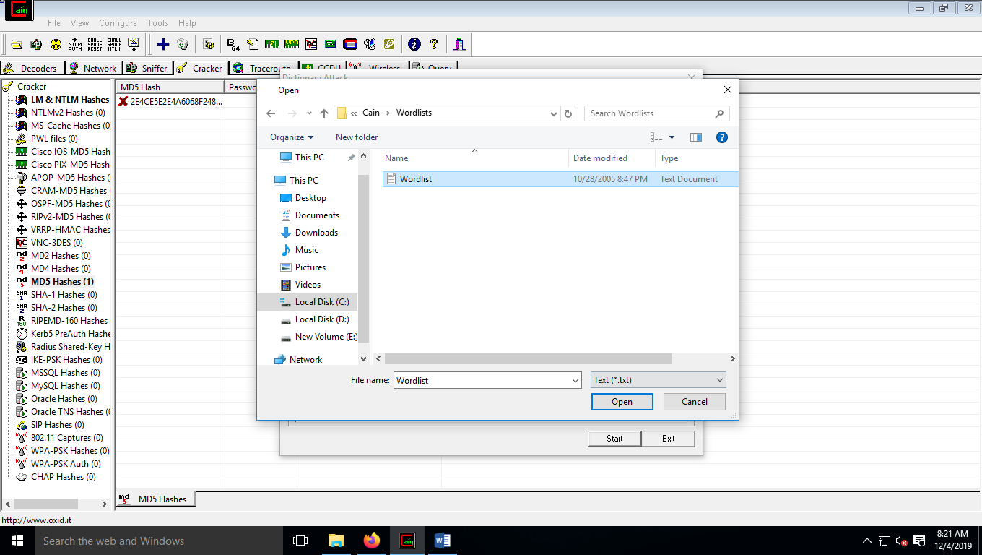

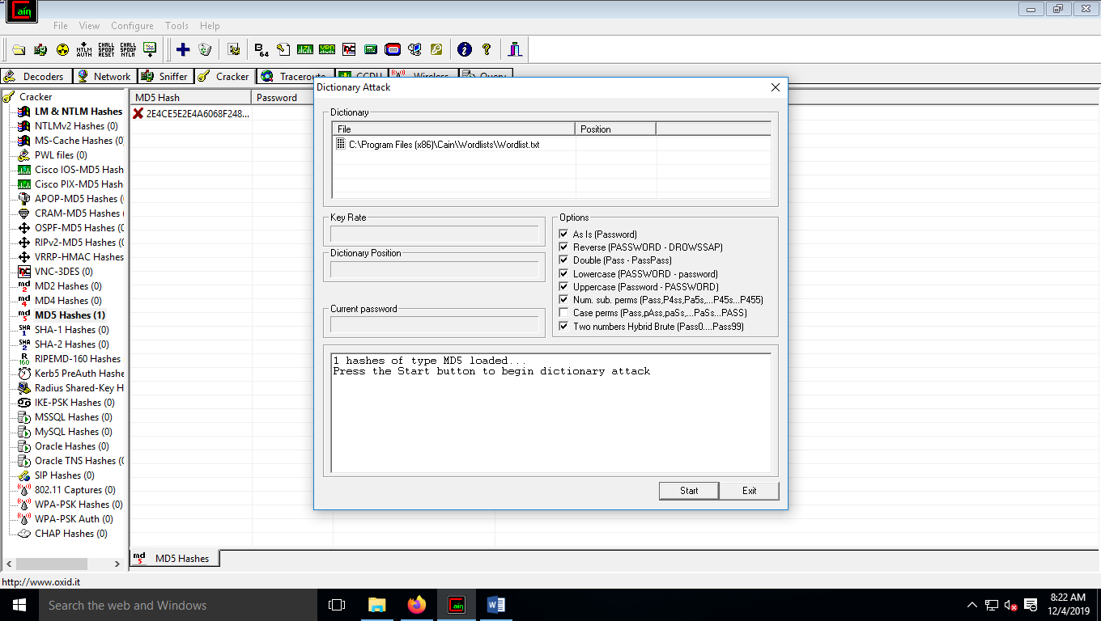

**The scan will begin**

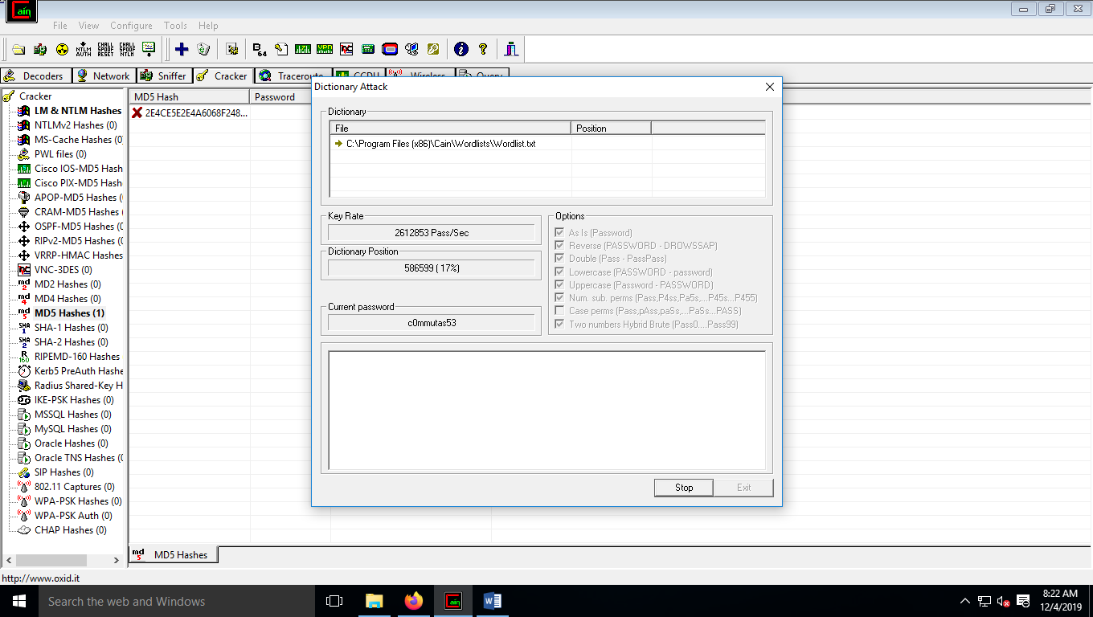

**And your password will be appeared from the dictionary**

